REAL WORLD DATA PROJECT
(FINANCE, HEALTH, or RETAIL)

Introduction:
Retail businesses generate large amounts of sales data every day. Analyzing this data helps companies understand customer behavior, seasonal trends, and product performance.
This project focuses on analyzing retail sales data and building a machine learning model to predict future sales based on quantity and discount.

The main objective is to:
- Analyze category-wise sales
- Identify monthly sales trends
- Predict sales using Linear Regression

Exploratory Data Analysis (EDA):
Category-wise Sales Analysis:
- Technology category generated higher overall sales compared to others.
- Some categories contribute more to revenue.
- Business Meaning: Companies should focus marketing efforts on high-performing categories.

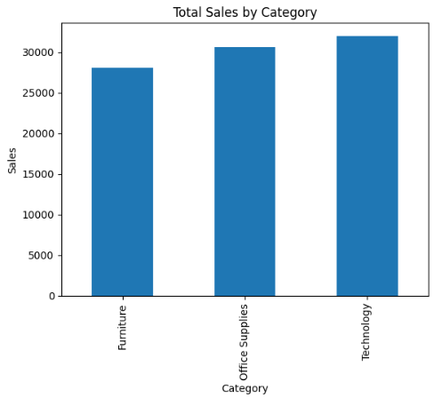

Montly Sales Trend Analysis:
- Sales fluctuate month-wise.
- Some months show peak performance.
- Seasonal patterns can be observed.
- Business Meaning: Retailers can plan stock and offers based on seasonal demand.

